In-situ investigation on cyclic bending deformation of oligo-crystalline 316LVM steel for coronary stent application with EBSD
Yitong Yangª, Sabine Weißª
ªBTU Cottbus-Senftenberg, Chair of Physical Metallurgy and Materials Technology, Konrad-Wachsmann-Allee 17, 03046 Cottbus, Germany and address
ªyitong.yang@b-tu.de
The objective of this work is to investigate the strain localization and slip activation of the microstructure of oligo-crystalline 316LVM steel struts evolving during different cyclic bending deformation stages (number of cycles) and loading conditions (maximum stress and neutral). A micro-scale three-point bending fixture was designed and incorporated into a micro tensile/compression machine to perform in-situ electron backscatter diffraction (EBSD) measurements during different phases of cyclic fatigue testing. Grain orientation based analyses are applied to indicate strain localization as well as dislocation distribution and grain orientation rotation during the deformation process. The following results were obtained: 1) The quantitative strain and dislocation distributions could be compared after each stage of deformation. 2) The rotation of the slip planes of the grains correlates with the Schmid factor and the grain boundary trace. The results contribute to the understanding of the evolution of the microstructure at low strain variations under bending fatigue conditions, and can support the prediction of the fatigue life of 316LVM stainless steel oligocrystalline microdevices like coronary stents.
Keywords:
Oligo-crystalline microstructure, in-situ bending fatigue test, EBSD strain localization, 316LVM austenitic steel, coronary stent,

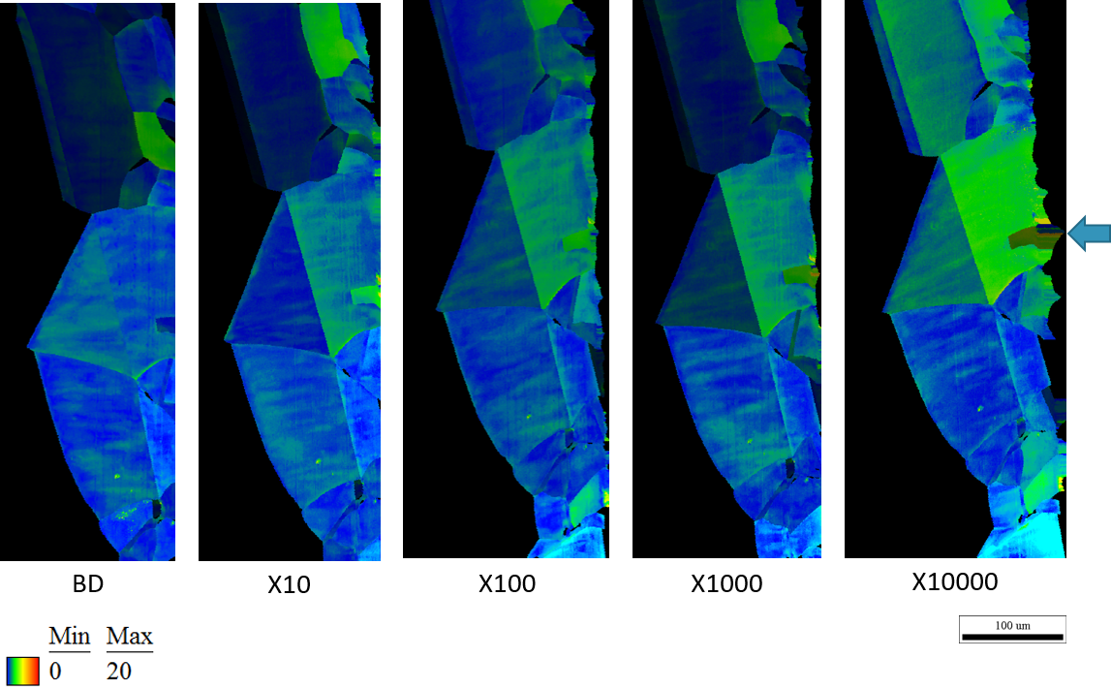
Fig 1. The GROD map of the compression part. Arrow indicates the bending point and direction. The color scale indicates the misorientation of the grain to the average orientation of the grain.
References:

