Creep degradation of the high entropy superalloy AlMo_{0.5}NbTa_{0.5}TiZr
Patricia Suárez Ocañoª, Christian Gadelmeier^{b}, Uwe Glatzel^{b} and Leonardo Agudo Jácome^{a,}*
ªBundesanstalt für Materialforschung und -Prüfung (BAM), Unter den Eichen 87, 12205 Berlin, Germany^{b}
ªLehrstuhl Metallische Werkstoffe, Universität Bayreuth, Prof.-Rüdiger-Bormann-Str. 1, 95447 Bayreuth, Germany
*Leonardo.Agudo@bam.de
The refractory high entropy superalloy (RSA) AlMo_{0.5}NbTa_{0.5}TiZr [1] was the first of a class, with a dual-phase microstructure that resembles that of γ/γ’ in Ni-base superalloys (Fig.1, left), and the open question whether it performs better as structural alloy under high temperature (HT) applications. Here, we address the HT creep behavior and its associated microstructural degradation of this RSA.
The material was produced by arc-melting, heat treatment in argon (24 h @ 1400 °C + 4 h hot isostatic pressure @ 1370 °C & 170 MPa). Interrupted vacuum creep tests were performed at 900-1100 °C and 30-120 MPa. Scanning (S) and transmission (T) electron microscopy (EM) were used to reveal degradation mechanisms.
At 1100 °C (Fig.1, middle), the dual A2/B2 microstructure coarsens and partially transforms into a Zr-Al-rich phase (red arrow). An additional external load pronounces directional coarsening (Fig.1, right). Results are further discussed on the base dislocation and additional damage mechanisms.
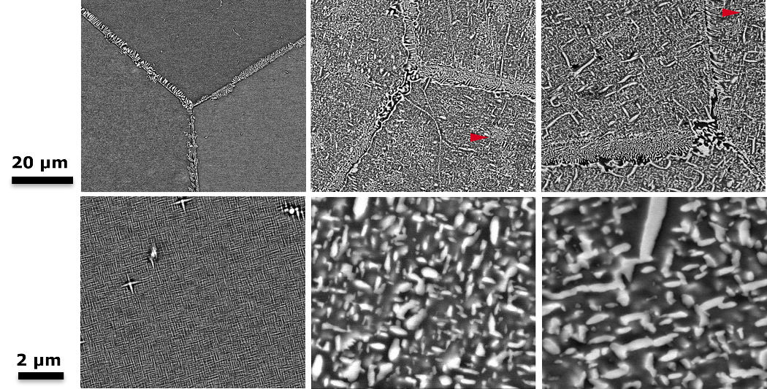
Fig.1 Low (top) and high (bottom) magnification backscattered electron images of RSA before creep (left), after load-free thermal exposure (middle) and after
Keywords: high entropy superalloy, rafting, dislocation creep, phase transformation.
[1] O.N. Senkov, D. Isheim, DN Seidman and AL Pilchak. Development of a refractory high entropy superalloy Entropy, 18, 2016, 102.

